1. select ename, job, deptno from emp where job='CLERK';

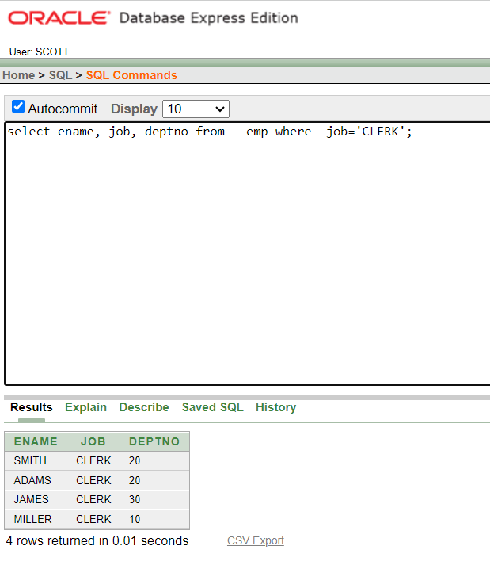

1. select ename, job, deptno from emp WHERE ename='JAMES';

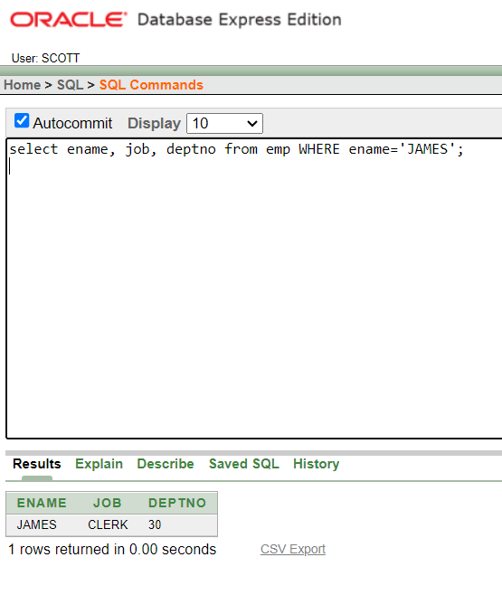

1. select ename, sal, comm from emp where sal<=comm;

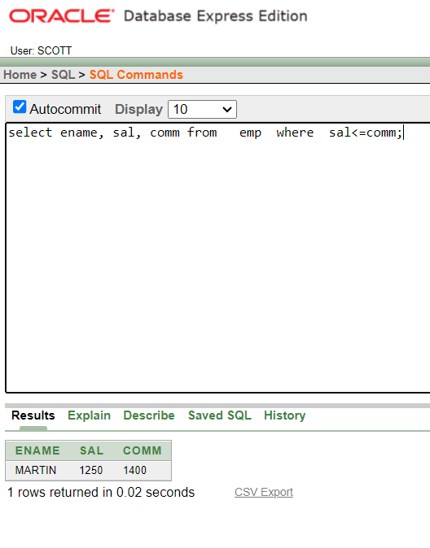

1. select ename, sal from emp where sal between 1000 and 1500;

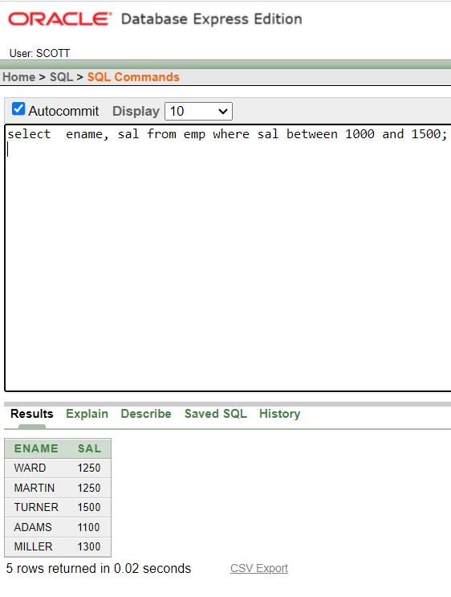

1. select empno, ename, sal, mgr from emp where mgr in (7902, 7566, 7788);

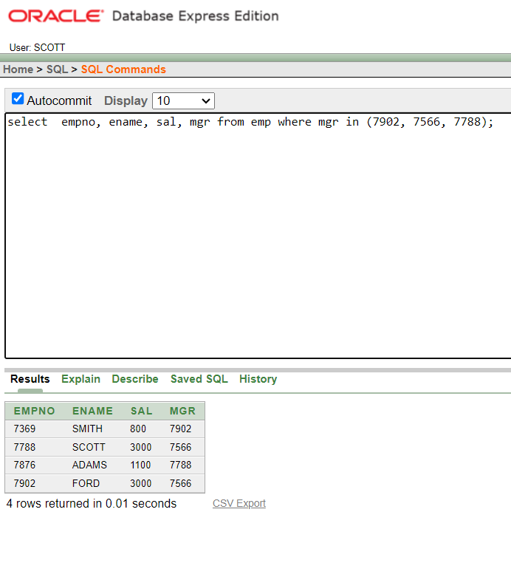

1. select ename from emp where ename like 'S%';

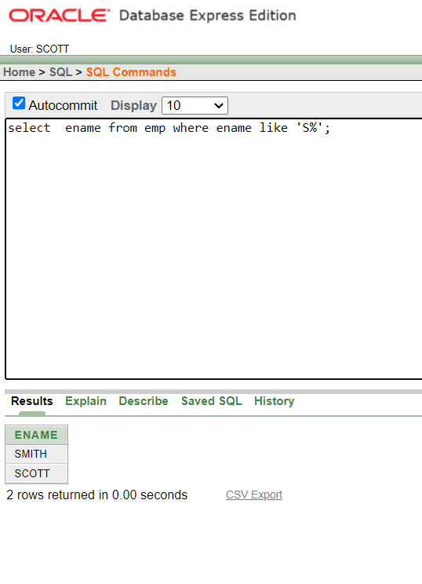

1. select ename from emp where ename like '_A%';

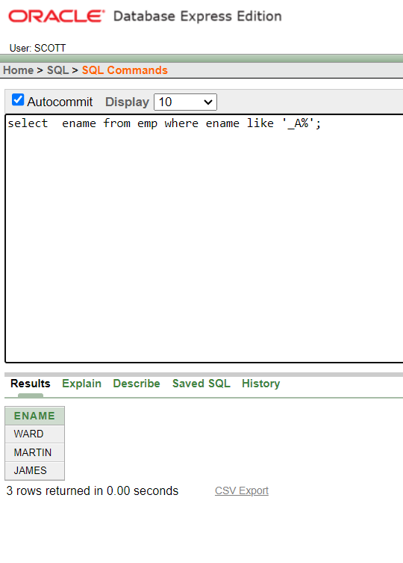

1. select ename, mgr from emp where mgr is null;

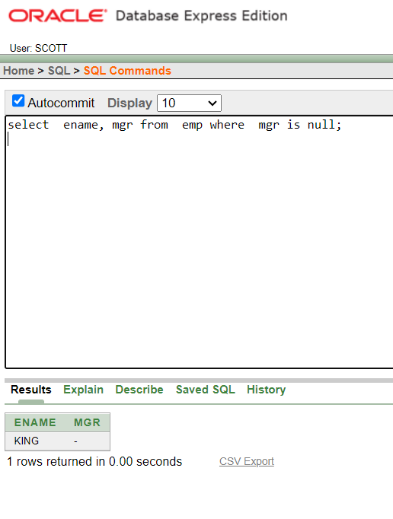

1. select empno, ename, job, sal from emp where sal>=1100 and job='CLERK';

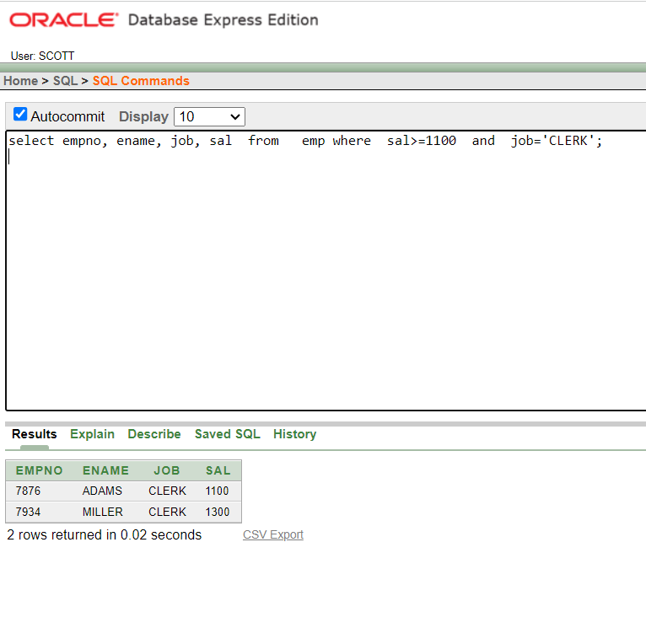

1. select empno, ename, job, sal from emp where sal>=1100 or job='CLERK';

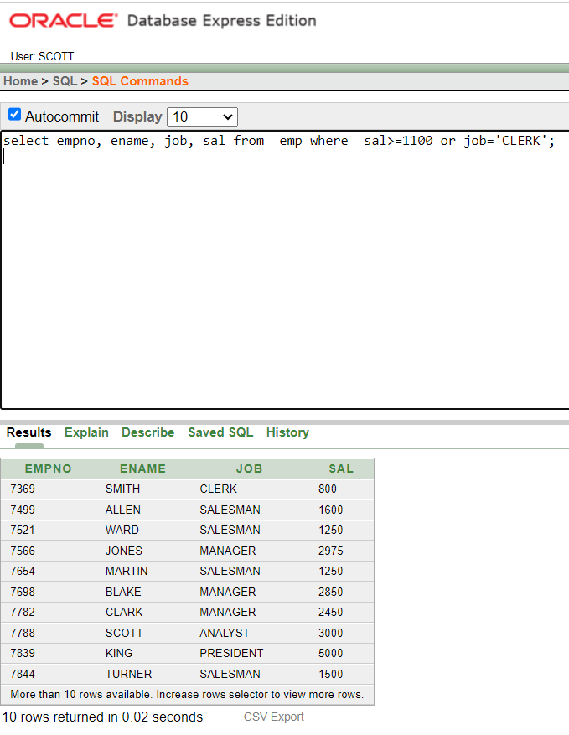

1. select ename, job from emp where job not in ('CLERK','MANAGER','ANALYST');

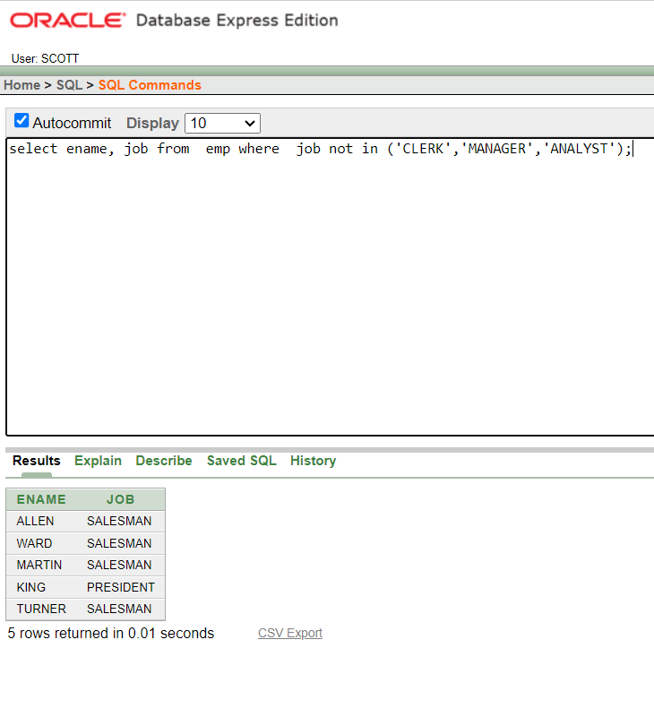

1. select ename, job, sal from emp where (job='SALESMAN' or job='PRESIDENT') and sal>1500;

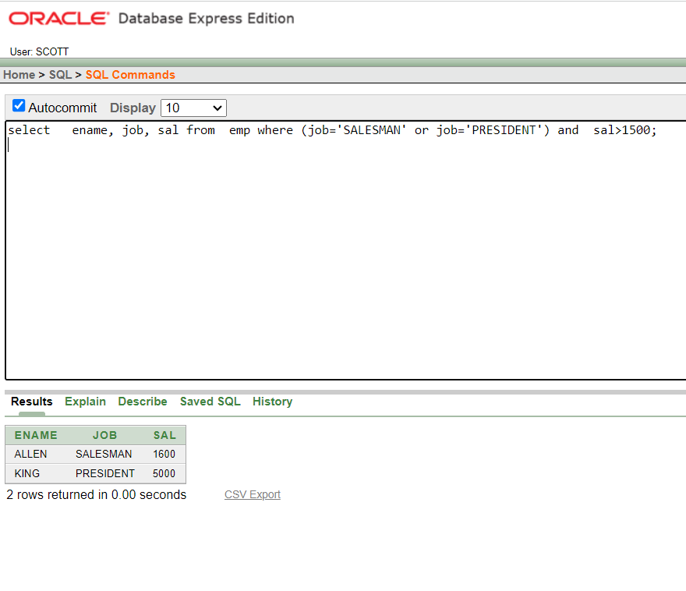

1. select ename, job, sal from emp where job='SALESMAN' or job='PRESIDENT' and sal>1500;

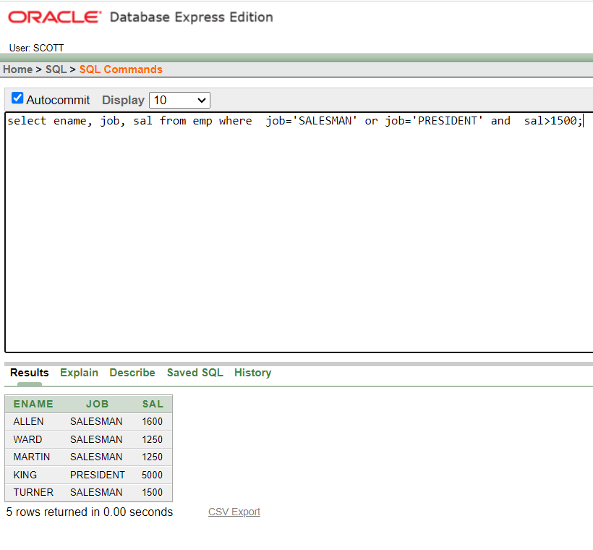

1. select ename, job, deptno, hiredate from emp order by hiredate;

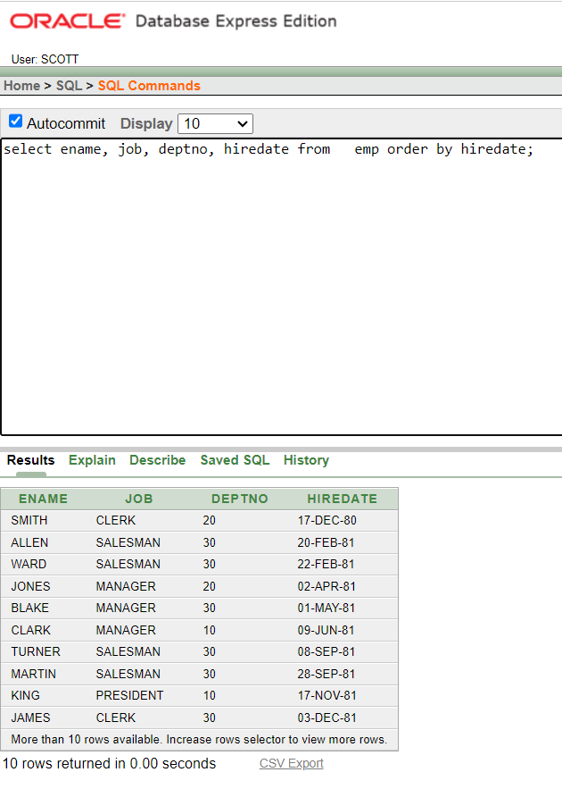

1. select ename, job, deptno, hiredate from emp order by hiredate desc;

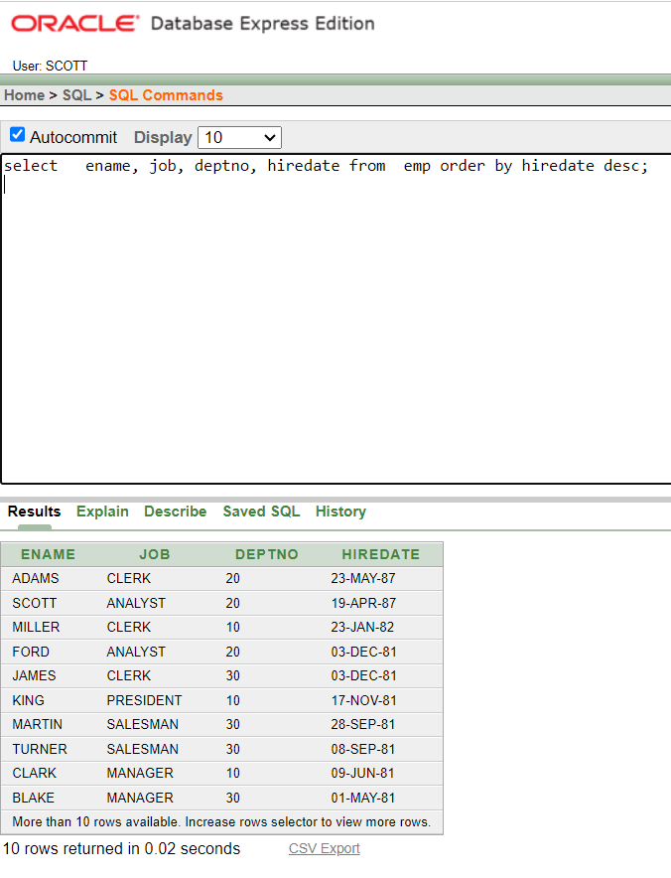

1. select empno, ename, sal*12 annsal from emp order by annsal;

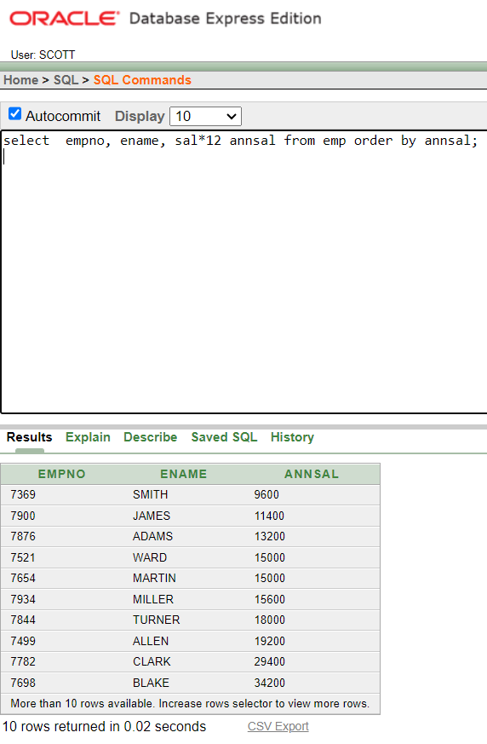

1. select ename, deptno, sal from emp order by deptno, sal desc;

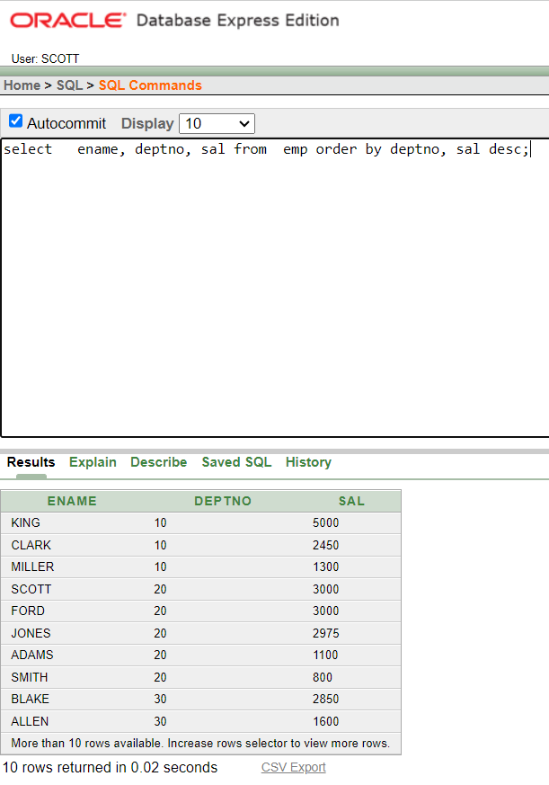

1. select AVG(sal), MAX(sal), MIN(sal), SUM(sal) from emp where job LIKE 'SALES%';

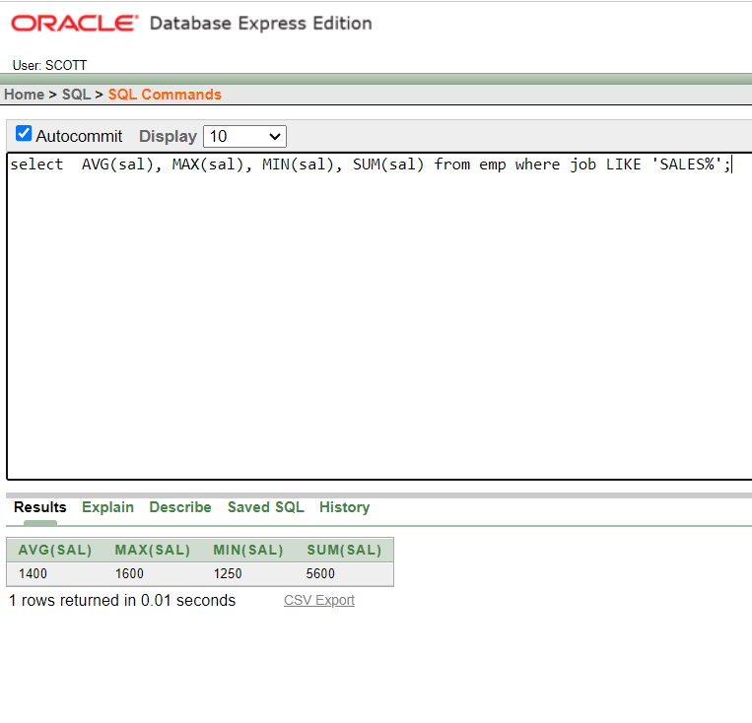

1. SELECT MIN(hiredate), MAX(hiredate) FROM emp;

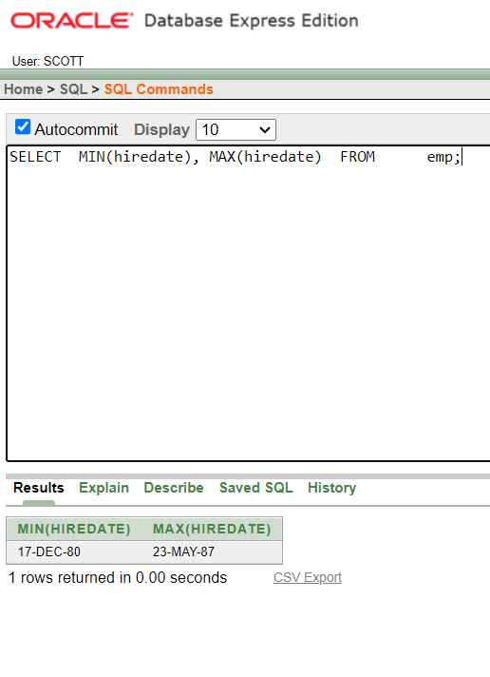

1. select count(*) from emp where deptno = 30;

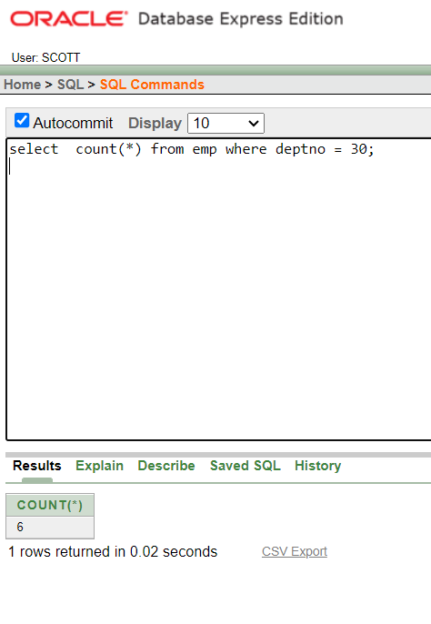

1. select count(comm) from emp where deptno = 30;

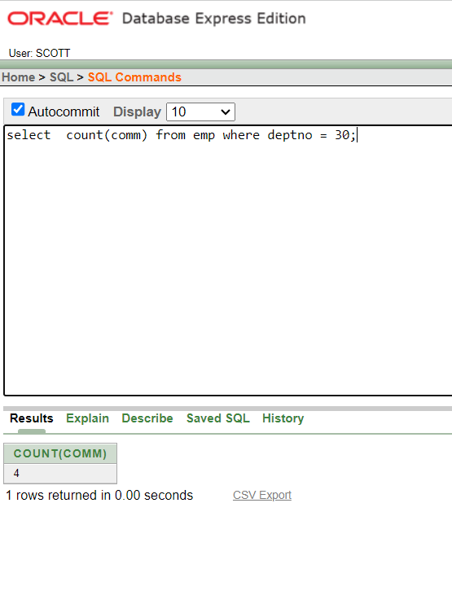

1. select avg(comm) from emp;

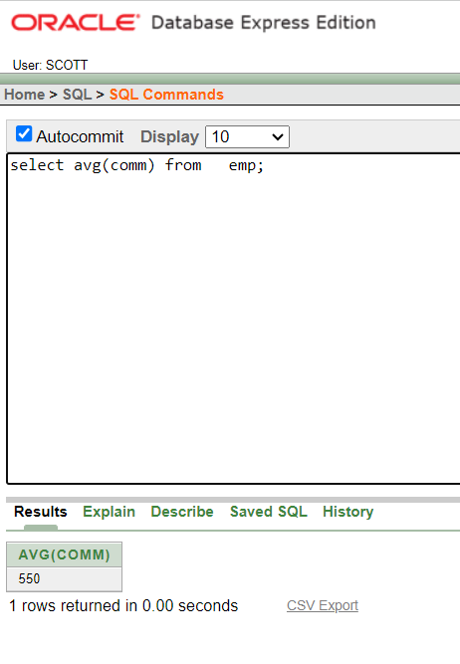

1. select deptno, avg(sal) from emp group by deptno;

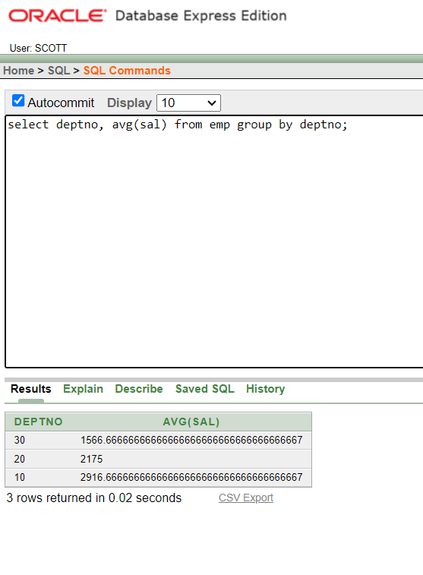

1. select deptno, avg(sal) from emp group by deptno;

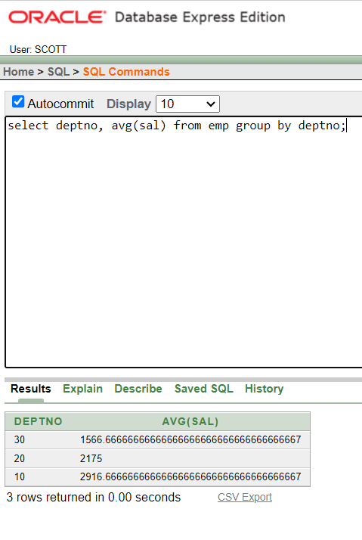

1. select deptno, job, sum(sal) from emp group by deptno, job;

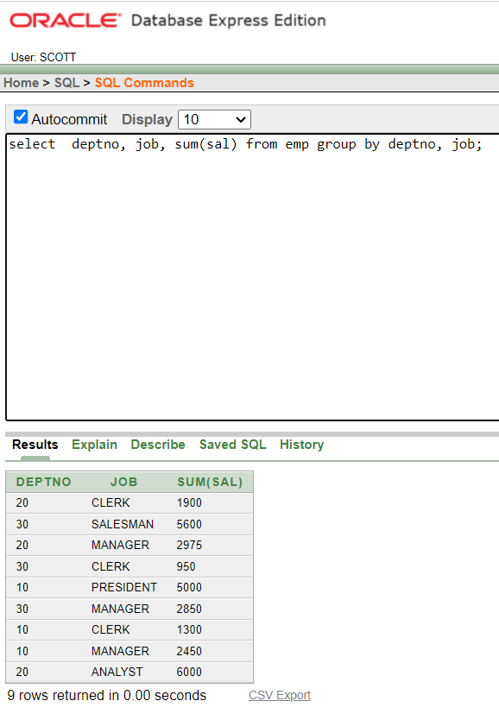

1. select deptno, max(sal) from emp group by deptno having max(sal)>2900;

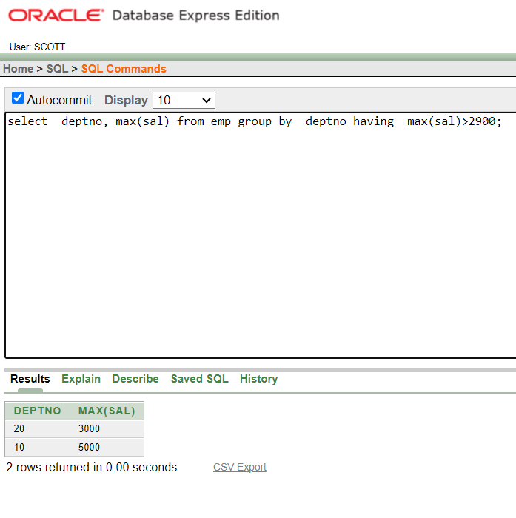

1. select deptno, max(sal) from emp group by deptno having max(sal)>2900;

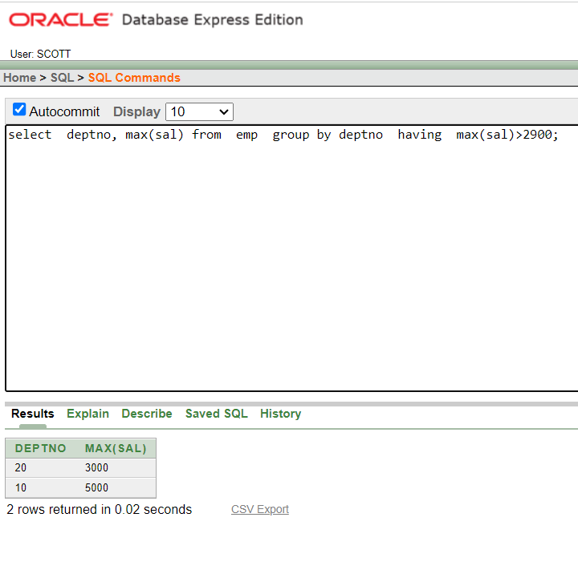

1. select job, sum(sal) payroll from emp where job not like 'SALES%' group by job having sum(sal)>5000 order by sum(sal);

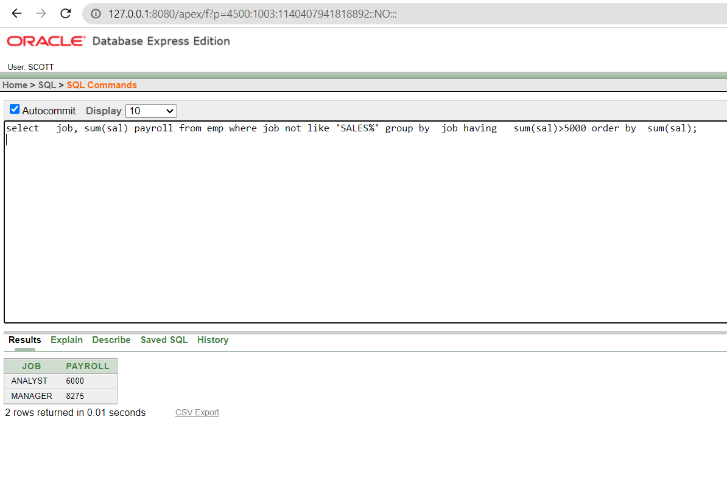

1. select max(avg(sal)) from emp group by deptno;

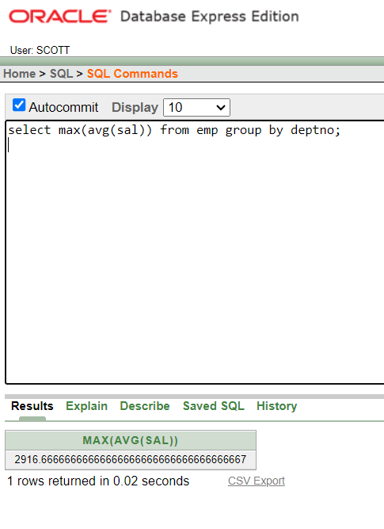

1. select empno, ename, deptno from emp where lower(ename) = 'blake';

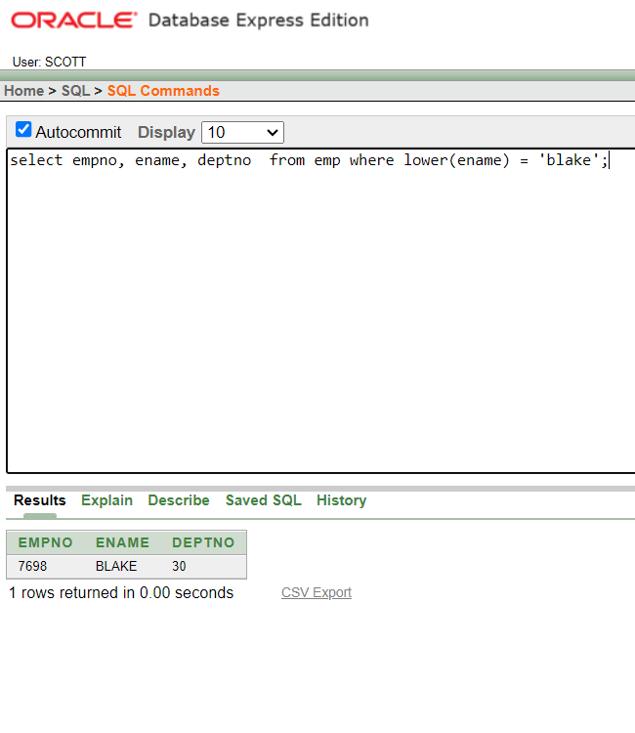

1. select ename, CONCAT (ename, job), LENGTH(ename), INSTR(ename, 'A') FROM emp WHERE SUBSTR(job,1,5) = 'SALES';

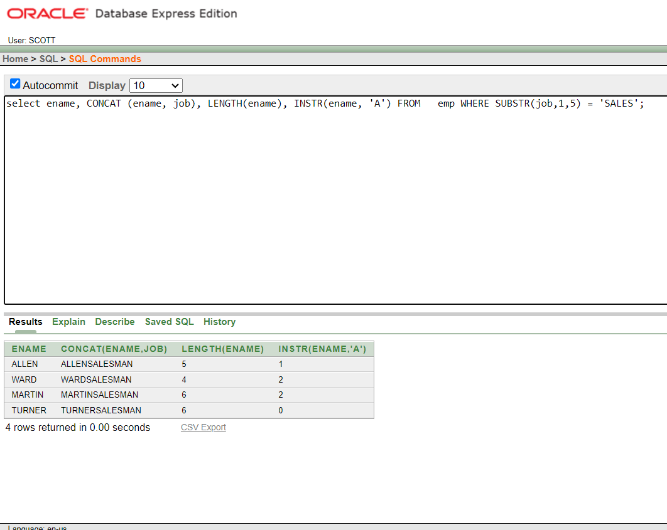

1. select round(45.923,2), round(45.923,0), round(45.923,-1) from dual;

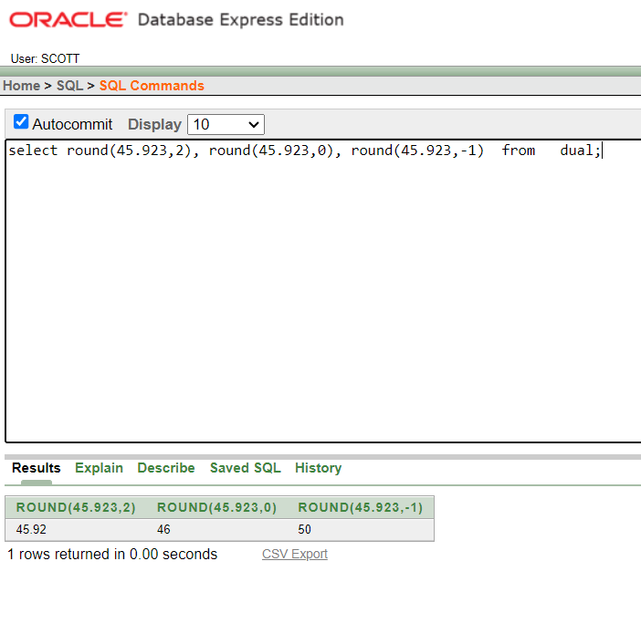

1. select TRUNC(45.923,2), TRUNC(45.923), TRUNC(45.923,-1) from dual;

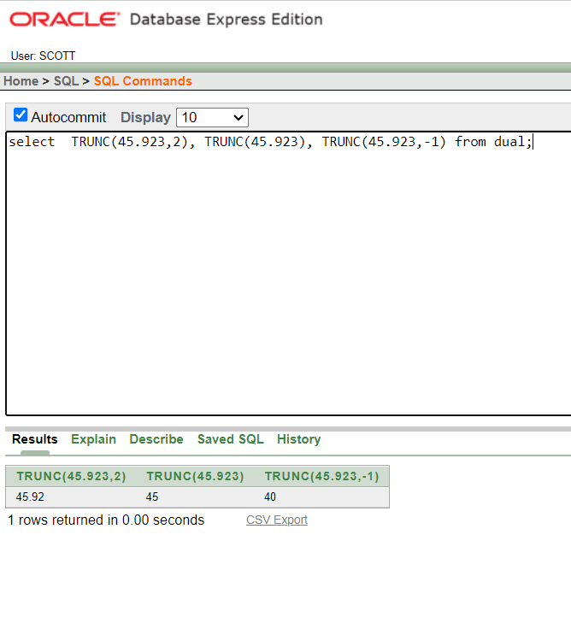

1. select ename, sal, comm, MOD(sal, comm) FROM emp WHERE job = 'SALESMAN';

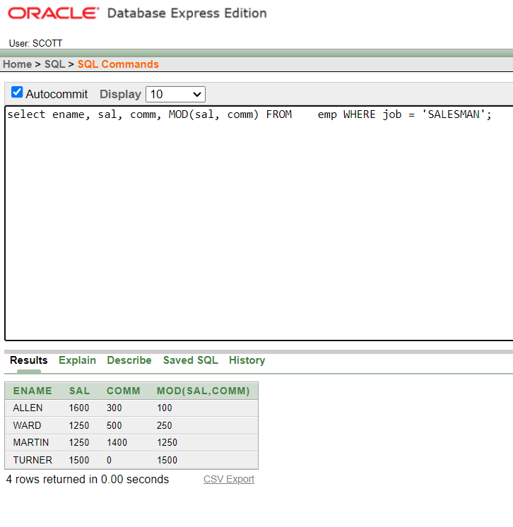

1. SELECT ename, (SYSDATE-hiredate)/7 WEEKS FROM emp WHERE deptno = 10;

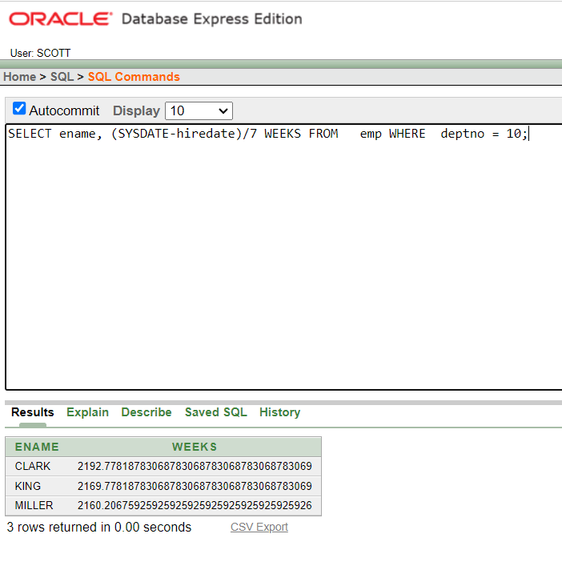

1. select ename, TO_CHAR(hiredate, 'fmDD Month YYYY') HIREDATE from emp;

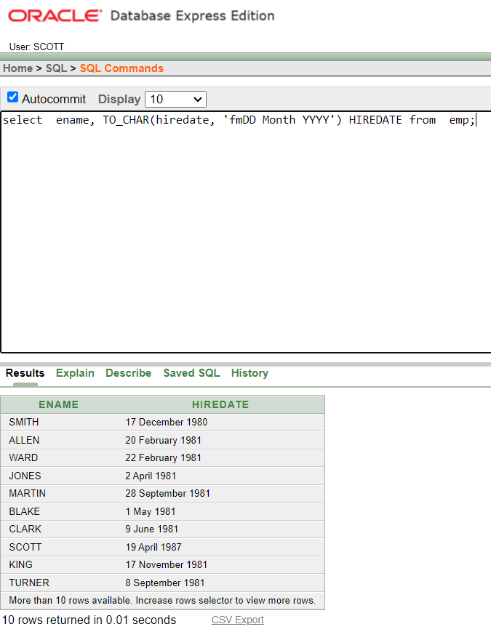

1. select TO_CHAR(sal,'$99,999') SALARY from emp WHERE ename = 'SCOTT';

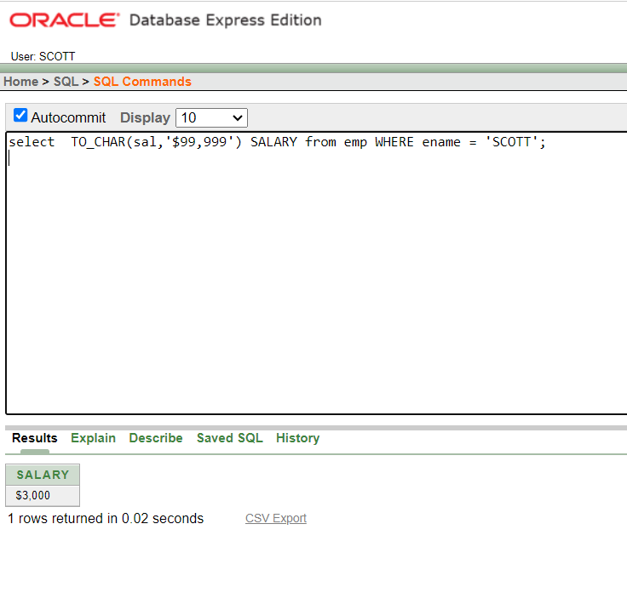

1. select ename, sal, comm, (sal*12)+NVL(comm,0) from emp;

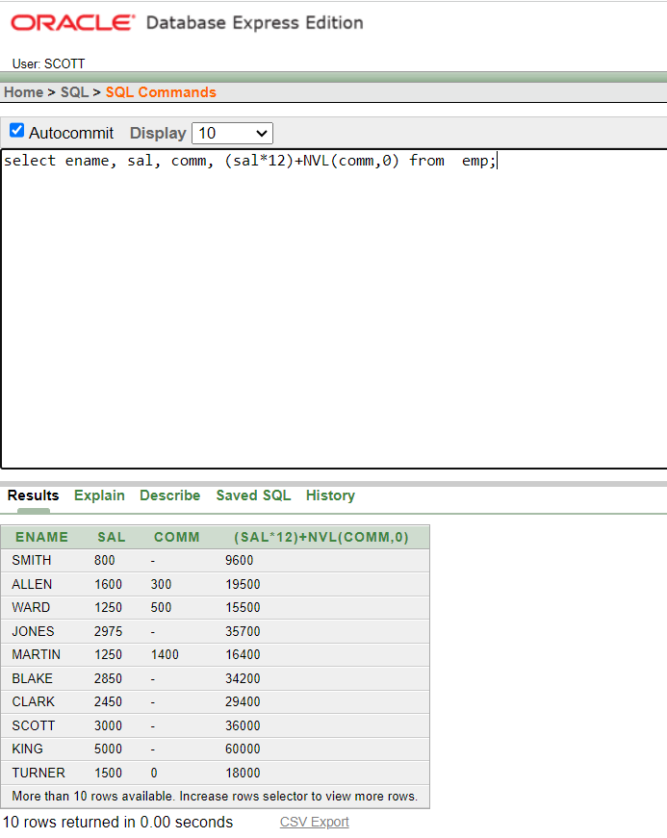

1. select job, sal,DECODE(job, 'ANALYST', SAL*1.1,'CLERK', SAL*1.15,'MANAGER', SAL*1.20,SAL)REVISED_SALARY FROM emp;

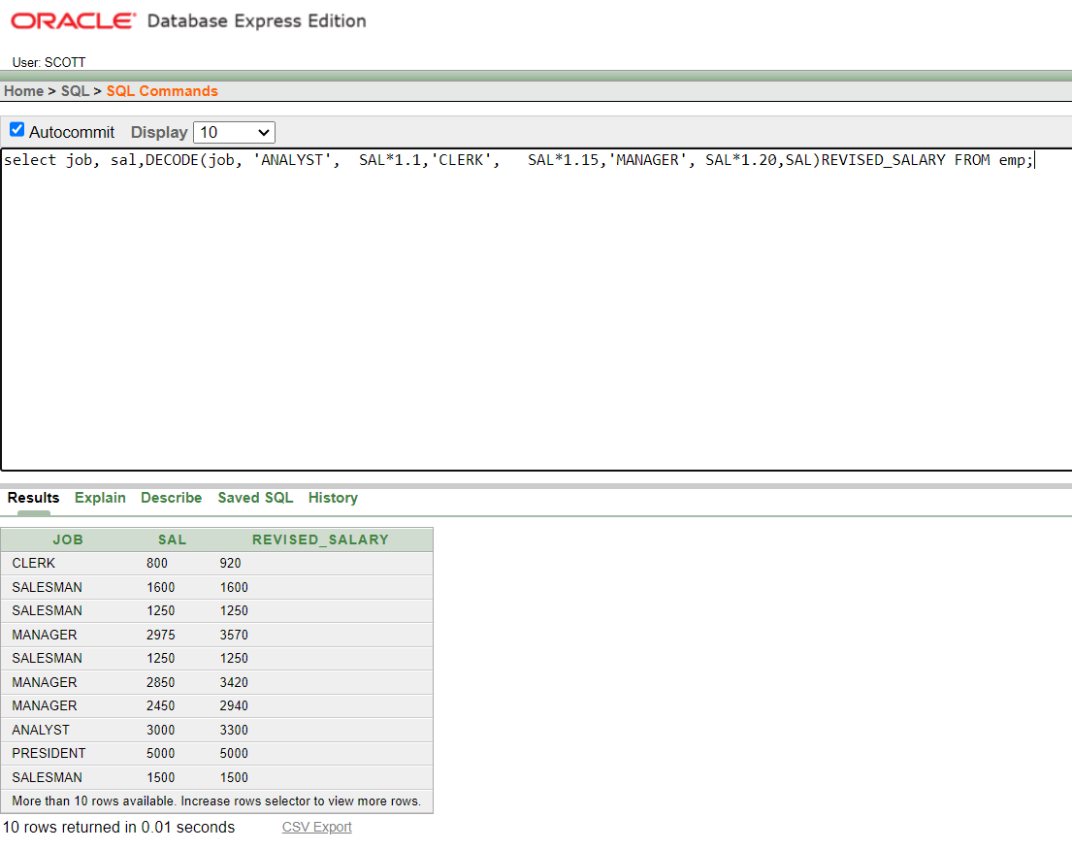

1. select ename, NVL(TO_CHAR(mgr),'No Manager') FROM emp WHERE mgr IS NULL;

